LAB - IoT

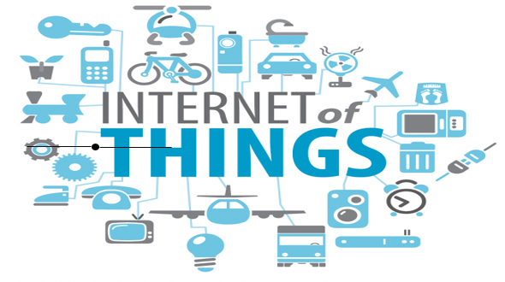

Objetivos

* Una breve revisión sobre IoT
* implementar nuestro primer IoT
* johnny-five framework
* Ios integration IoT

Que IoT ?

El **Internet of Things** es el siguiente gran paso de la industria tecnológica Muy resumidamente, el **Internet of Things** es un concepto que se basa en la interconexión de cualquier producto con cualquier otro de su alrededor.

Install Johnny-five on Arduino

Para Instalar Johnny-five ejecutar el siguiente comando:

$ npm install johnny-five

If the above didn't work as expected, make sure that StandardFirmata is installed on the board:

* Download [Arduino IDE](http://arduino.cc/en/main/software)
* Download NodeJs: <https://nodejs.org/es/download/>
* Plug in your Arduino or Arduino compatible microcontroller via USB
* Open the Arduino IDE, select: File > Examples > Firmata > StandardFirmata
* Click the "Upload" button.
* If the upload was successful, the board is now prepared and you can close the Arduino IDE.

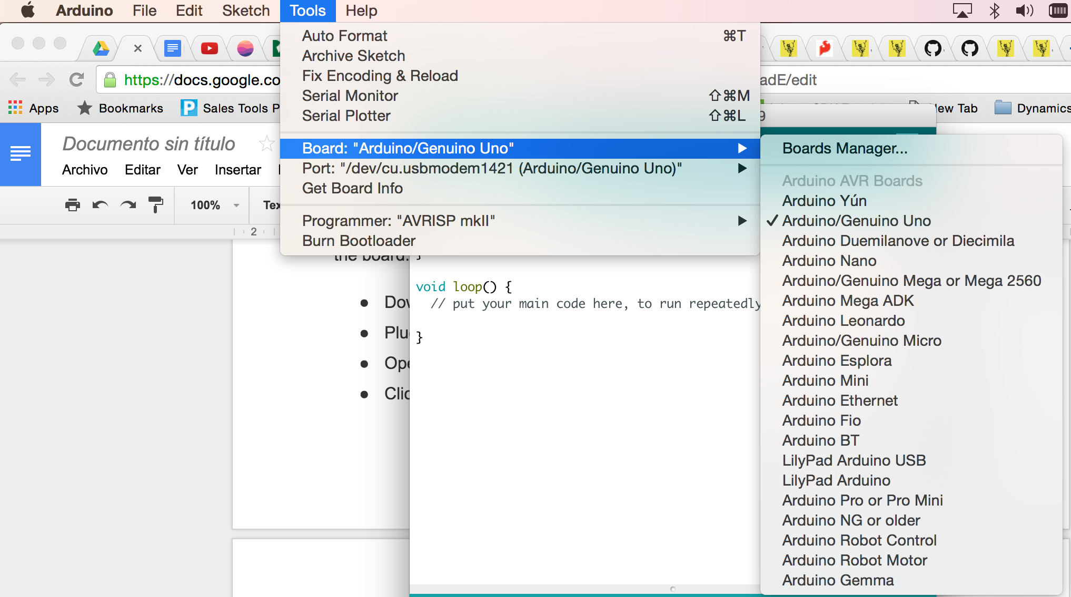

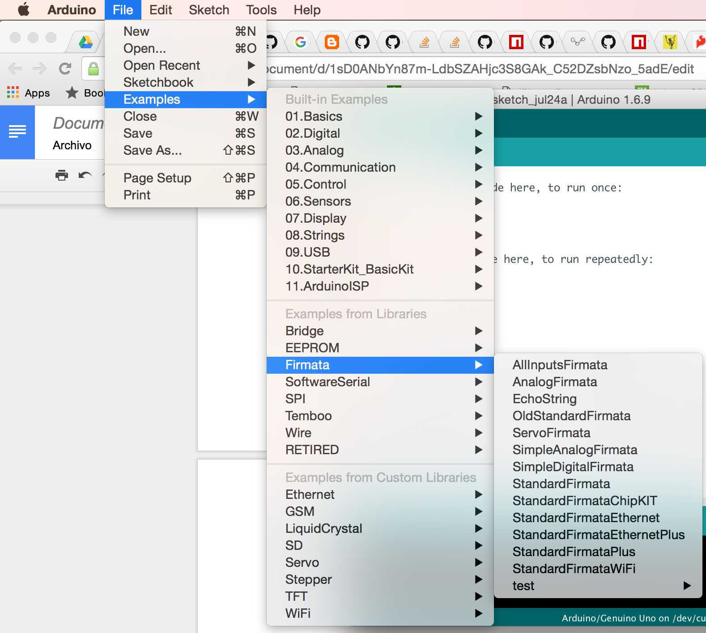

Upload Firmata standart

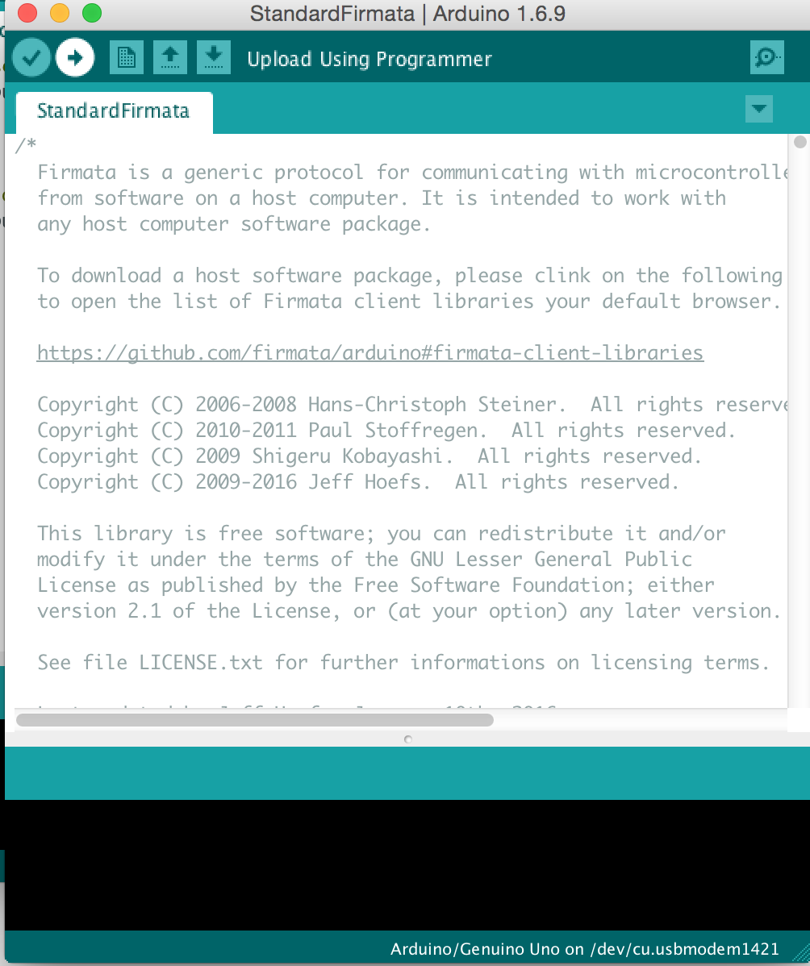

<https://github.com/rwaldron/johnny-five/wiki/Getting-Started#trouble-shooting>

## Preparar el Servidor IoT

Instalar johnny-five : http://johnny-five.io/

1. Install [Node.js (Prefer 4.2.1 LTS)](https://nodejs.org/download/).
2. [Setup your board.](http://johnny-five.io/platform-support/)
3. Run: npm install johnny-five

Run Hello world

create a file example.js and put the following code

var five = require("johnny-five");  
var board = new five.Board();  
  
board.on("ready", function() {  
 // Create an Led on pin 13  
 var led = new five.Led(13);  
 // Blink every half second  
 led.blink(500);  
});

Run

node example.js

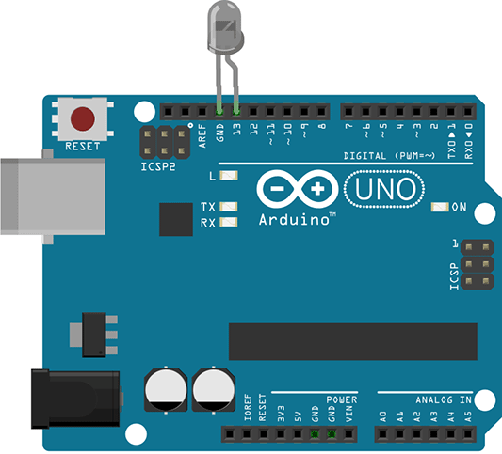

Correr Rest/API con johnny-five

Descargar arduinoControl.zip y correr el siguiente comando

$ npm install

$ npm start

Prender el LED

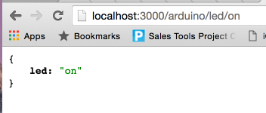

Apagar el LED

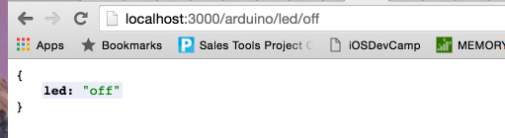

Crear la Interfaz

Create new Xcode project Single View and add Cocoa pods project:

* pod init
* Open Podfile and edit with following information:

pod 'Alamofire', '~> 4.5'

* uncoment #platform :ios, '9.0' of podfile

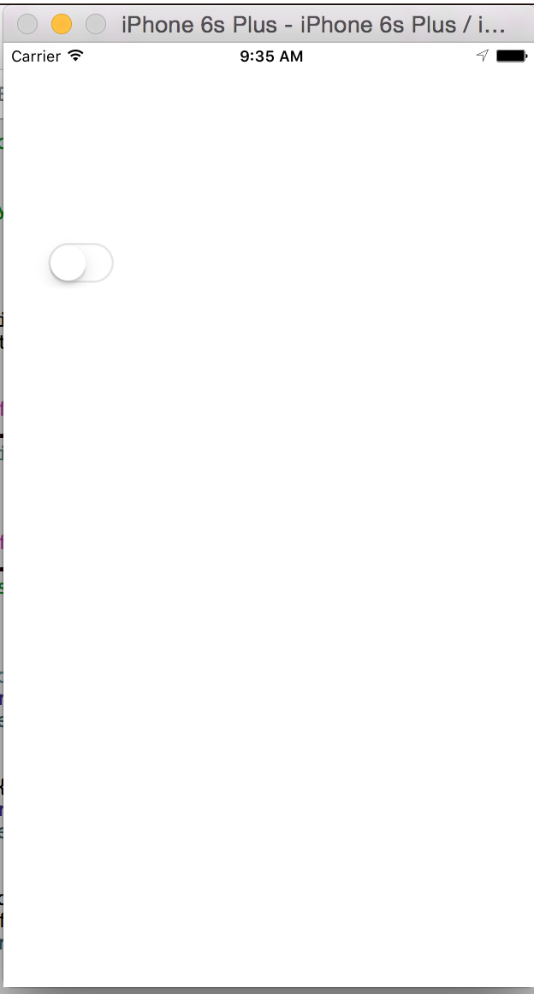

Configure insecure No HTTPS end point

<key>NSAppTransportSecurity</key>

<dict> <!--Include to allow all connections (DANGER)--> <key>NSAllowsArbitraryLoads</key>

<true/>

</dict>

Conextar el UIswitch con el código

//

// ViewController.swift

// LEDONOFF

//

// Created by jhonny on 7/26/16.

// Copyright © 2016 Viva. All rights reserved.

//

import UIKit

import Alamofire

class ViewController: UIViewController {

@IBOutlet weak var ledswitch: UISwitch!

override func viewDidLoad() {

super.viewDidLoad()

ledswitch.on = false

// Do any additional setup after loading the view, typically from a nib.

}

override func didReceiveMemoryWarning() {

super.didReceiveMemoryWarning()

// Dispose of any resources that can be recreated.

}

@IBAction func ledAction(sender: AnyObject) {

if(ledswitch.on){

print("on switch")

ledControl("on")

}else{

print("off switch")

ledControl("off")

}

}

func ledControl(status:String) {

Alamofire.request("http://localhost:3000/arduino/led/\(status)", method: .get).responseJSON { response in

// TODO implement

}

}

}